**Problem Definition**

You were given a dataset (in 2 CSV files) representing the history of temperatures of the world in around 270 years, the schema of the data is as shown below:

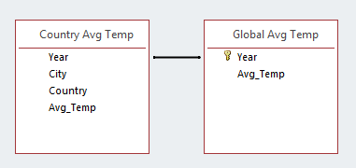

*Figure 1 Data Tables Schema*

You are asked to use the dataset to do the following requirements:

1- Using **KNIME Analytics Software**:

1.       Output a table that has the overall average of each country.

|  |  |
| --- | --- |
| Country | Avg_Temp |
| Afghanistan | 14.36 |
| Albania | 15.50 |
| Algeria | 16.43 |
| Angola | 23.69 |

2.       Classify the countries Temperature into “Low/Mid/High” ( **EXAMPLE**: **IF** the max temp is 90 and the min temp is 0 then from 0 to 30 is “Low”, from 30 to 60 “Mid”, from 60 to 90 “High” ).

|  |  |
| --- | --- |
| Country | Class |
| Afghanistan | Mid |
| Albania | Mid |
| Algeria | Mid |
| Angola | High |
| Argentina | Mid |

3.       Output a table that has the difference between the average of the country **in each year** and the average global temp in the last 24 years.

|  |  |  |
| --- | --- | --- |
| Year | Country | Difference |
| 2001 | Afghanistan | -6.4 |
| 2001 | Albania | -7.2 |
| 2001 | Algeria | -8.7 |
| 2001 | Angola | -15.0 |
| 2001 | Argentina | -8.7 |

4.       Output a table that shows the top 5 countries that have the largest difference from the global Temp.

|  |  |
| --- | --- |
| Country | Difference |
| …… | …. |
| …. | … |
| … | … |

      5. Draw a histogram for the yearly global temperatures

      6. Choose any city and draw a chart to compare between this city and global average temperature over the past years